Machine learning Lab Observation
ITA0614

Experiment 1

Implement and demonstrate the FIND-S algorithm for finding the most specific hypothesis based on a given set of training data samples.

Name : G.B.Hari Haran
Reg.No : 192412390

Problem 1 : Enjoy sport
Aim
To implement the FIND-S algorithm in Python on the EnjoySport training data stored in a list and to obtain the most specific hypothesis.
Algorithm
- Initialise h to the most specific hypothesis in H: h = <0, 0, ..., 0>.
- For each training example x:
(a) If x is a negative example, ignore it.
(b) If x is a positive example, then for each attribute constraint ai in h:
if ai is satisfied by x, do nothing; otherwise replace ai by the next more general constraint that is satisfied by x (the first positive example copies its values; later mismatches become "?").
- Output the hypothesis h.
Program:
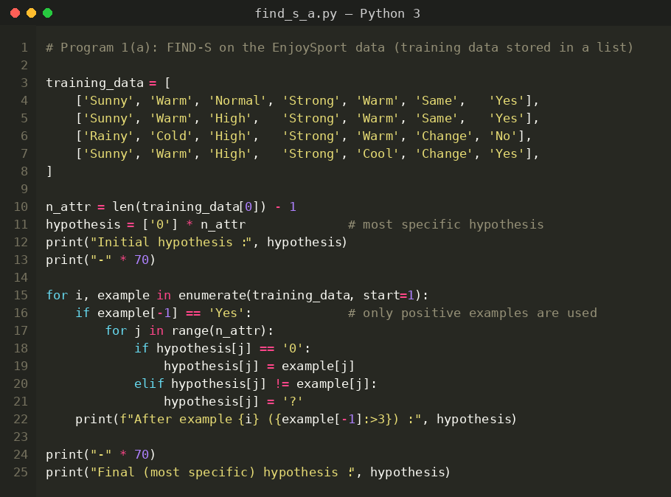
Input
EnjoySport data set: 4 training examples, 6 attributes (Sky, AirTemp, Humidity, Wind, Water, Forecast) and the target concept EnjoySport (Yes = positive, No = negative). The data is hard-coded in the program as a list of lists.
Sky | AirTemp | Humidity | Wind | Water | Forecast | EnjoySport
Sunny | Warm | Normal | Strong | Warm | Same | Yes
Sunny | Warm | High | Strong | Warm | Same | Yes
Rainy | Cold | High | Strong | Warm | Change | No
Sunny | Warm | High | Strong | Cool | Change | Yes
Output
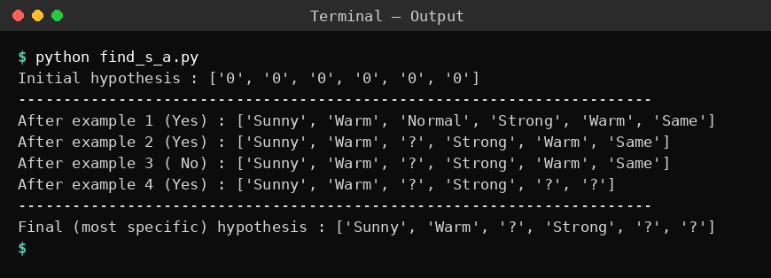
Result
The FIND-S algorithm was implemented and executed successfully. The most specific hypothesis consistent with the positive examples is <Sunny, Warm, ?, Strong, ?, ?>; the negative example (Rainy, Cold, ...) did not change the hypothesis.
Problem 2: Play Cricket
Aim
To implement the FIND-S algorithm by reading the training examples from a .CSV file using the csv module of Python.
Algorithm
- Initialise h to the most specific hypothesis in H: h = <0, 0, ..., 0>.
- For each training example x:
(a) If x is a negative example, ignore it.
(b) If x is a positive example, then for each attribute constraint ai in h:
if ai is satisfied by x, do nothing; otherwise replace ai by the next more general constraint that is satisfied by x (the first positive example copies its values; later mismatches become "?").
- Output the hypothesis h.
Program:
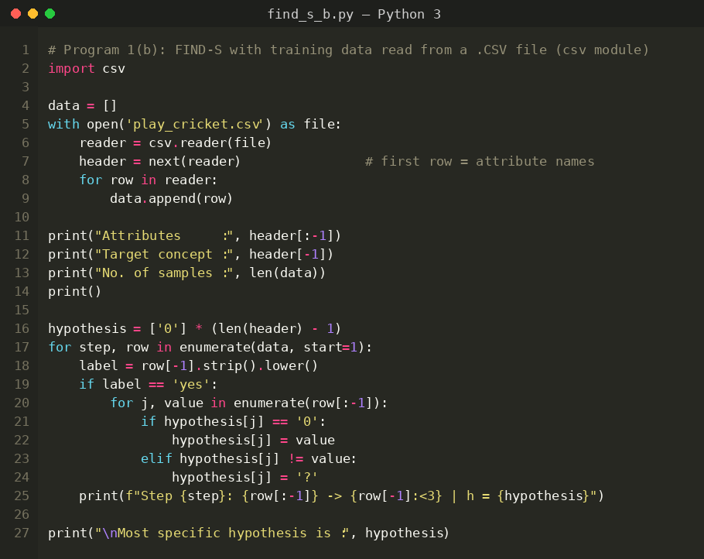
Input
PlayCricket data set (play_cricket.csv): 5 examples, 4 attributes (Outlook, Temperature, Humidity, Wind) and the target concept PlayCricket (Yes / No). The first row of the file holds the attribute names.
Outlook | Temperature | Humidity | Wind | PlayCricket
Sunny | Mild | Normal | Weak | Yes
Rainy | Mild | Normal | Weak | No
Sunny | Hot | Normal | Weak | Yes
Sunny | Hot | High | Strong | No
Sunny | Cool | High | Weak | Yes
Output
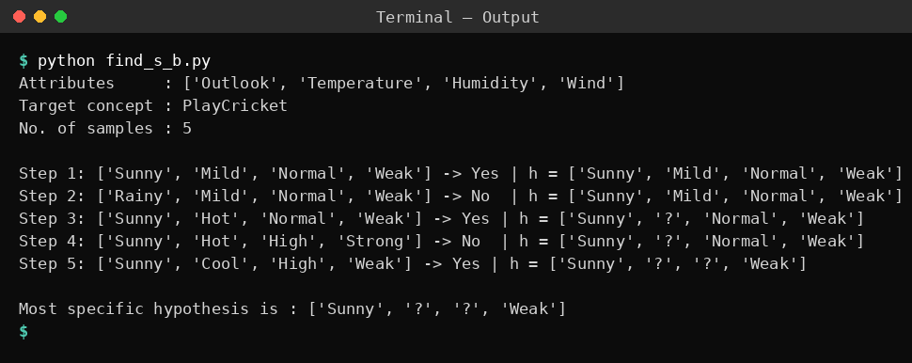
Result
The FIND-S algorithm was executed on the data read from the CSV file. The most specific hypothesis obtained is <Sunny, ?, ?, Weak>, i.e. cricket is played when the outlook is Sunny and the wind is Weak.
Problem 3: Buy Laptop
Aim
To implement the FIND-S algorithm using pandas DataFrame operations and find the most specific hypothesis for the Buy Laptop data.
Algorithm
- Initialise h to the most specific hypothesis in H: h = <0, 0, ..., 0>.
- For each training example x:
(a) If x is a negative example, ignore it.
(b) If x is a positive example, then for each attribute constraint ai in h:
if ai is satisfied by x, do nothing; otherwise replace ai by the next more general constraint that is satisfied by x (the first positive example copies its values; later mismatches become "?").
- Output the hypothesis h.
Program:
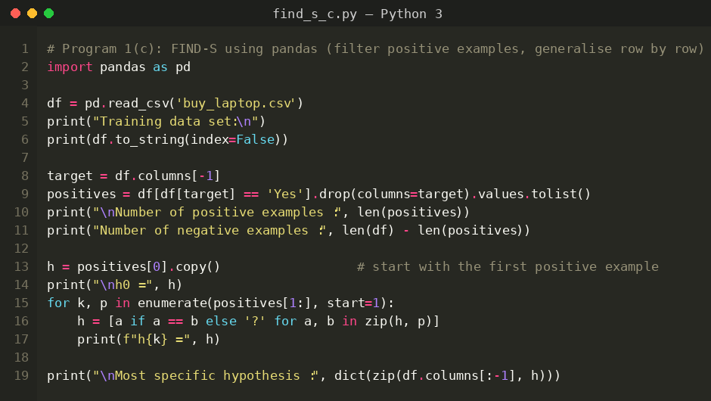
Input
Buy Laptop data set (buy_laptop.csv): 6 examples, 4 attributes (Brand, RAM, Storage, Price) and the target concept Buy (Yes / No), loaded into a pandas DataFrame.
Brand | RAM | Storage | Price | Buy
Dell | 8GB | SSD | Low | Yes
HP | 4GB | HDD | High | No
Dell | 8GB | SSD | Medium | Yes
Dell | 4GB | HDD | High | No
Dell | 16GB | SSD | Medium | Yes
Lenovo | 8GB | SSD | Low | No
Output
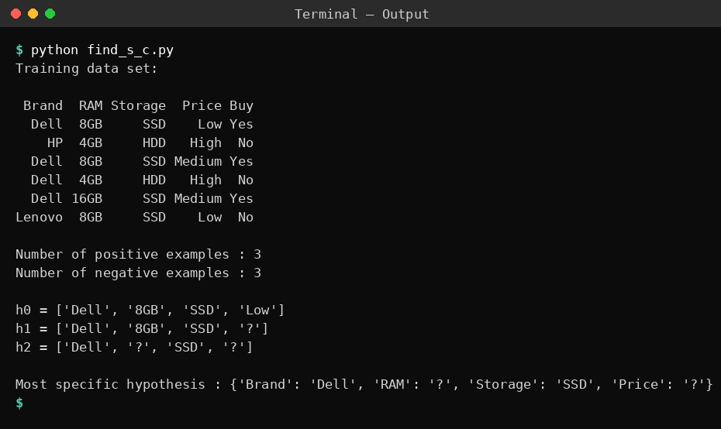
Result
FIND-S was implemented with pandas. The most specific hypothesis is <Dell, ?, SSD, ?>: the laptop is bought when the brand is Dell and the storage is SSD, irrespective of RAM and price.
Problem 4: Mushroom
Aim
To implement FIND-S using user-defined functions, show the hypothesis after every training example in a trace table and use the learned hypothesis to classify new samples.
Algorithm
- Initialise h to the most specific hypothesis in H: h = <0, 0, ..., 0>.
- For each training example x:
(a) If x is a negative example, ignore it.
(b) If x is a positive example, then for each attribute constraint ai in h:
if ai is satisfied by x, do nothing; otherwise replace ai by the next more general constraint that is satisfied by x (the first positive example copies its values; later mismatches become "?").
- Output the hypothesis h.
Program:
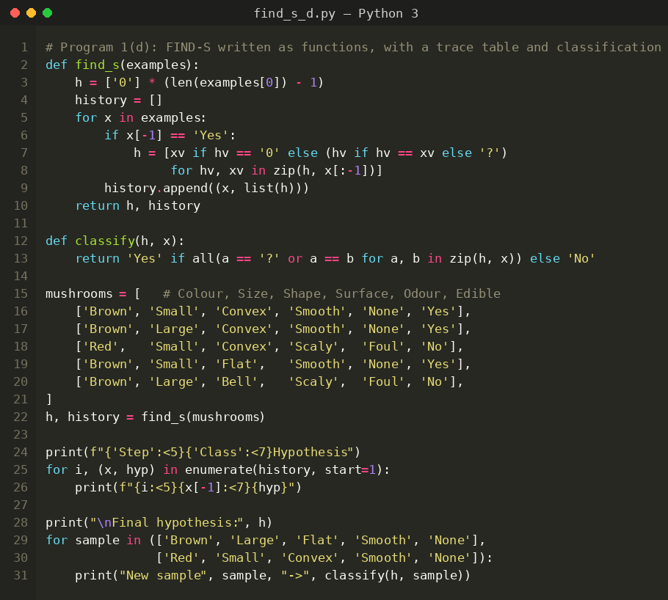
Input
Mushroom data set: 5 examples, 5 attributes (Colour, Size, Shape, Surface, Odour) and the target concept Edible (Yes / No). The data is stored in the program.
Colour | Size | Shape | Surface | Odour | Edible
Brown | Small | Convex | Smooth | None | Yes
Brown | Large | Convex | Smooth | None | Yes
Red | Small | Convex | Scaly | Foul | No
Brown | Small | Flat | Smooth | None | Yes
Brown | Large | Bell | Scaly | Foul | No
Output
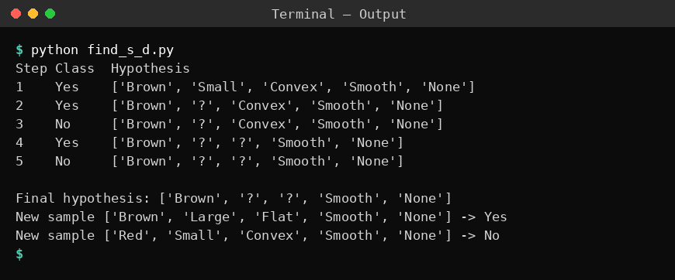
Result
The most specific hypothesis found is <Brown, ?, ?, Smooth, None>. Using it, the new sample (Brown, Large, Flat, Smooth, None) is classified as edible (Yes) and (Red, Small, Convex, Smooth, None) as not edible (No).
Problem 5: Bank loan approval
Aim
To implement FIND-S using NumPy arrays and verify that the hypothesis covers all positive and no negative examples of the loan data.
Algorithm
- Initialise h to the most specific hypothesis in H: h = <0, 0, ..., 0>.
- For each training example x:
(a) If x is a negative example, ignore it.
(b) If x is a positive example, then for each attribute constraint ai in h:
if ai is satisfied by x, do nothing; otherwise replace ai by the next more general constraint that is satisfied by x (the first positive example copies its values; later mismatches become "?").
- Output the hypothesis h.
Program:
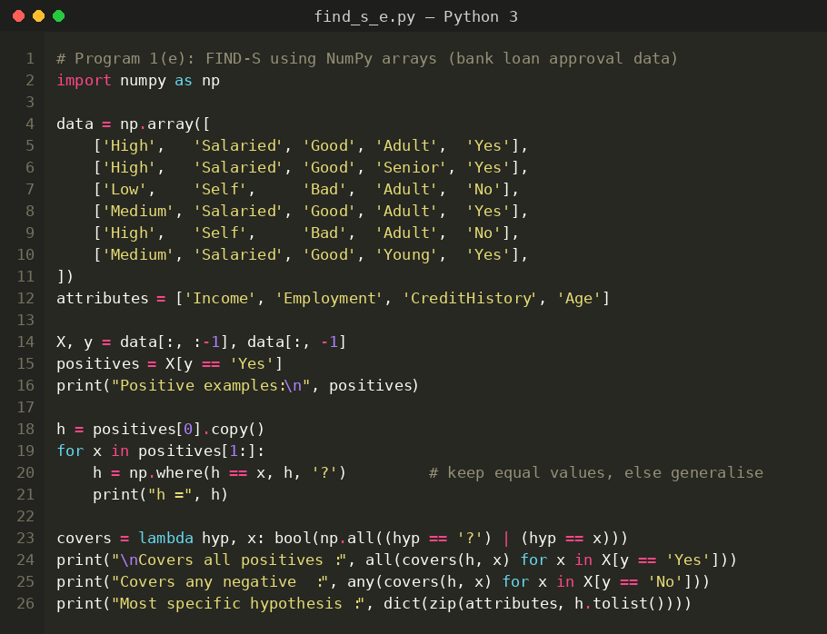
Input
Bank Loan data set: 6 examples, 4 attributes (Income, Employment, CreditHistory, Age) and the target concept Approved (Yes / No), stored as a NumPy string array.
Income | Employment | CreditHistory | Age | Approved
High | Salaried | Good | Adult | Yes
High | Salaried | Good | Senior | Yes
Low | Self | Bad | Adult | No
Medium | Salaried | Good | Adult | Yes
High | Self | Bad | Adult | No
Medium | Salaried | Good | Young | Yes
Output
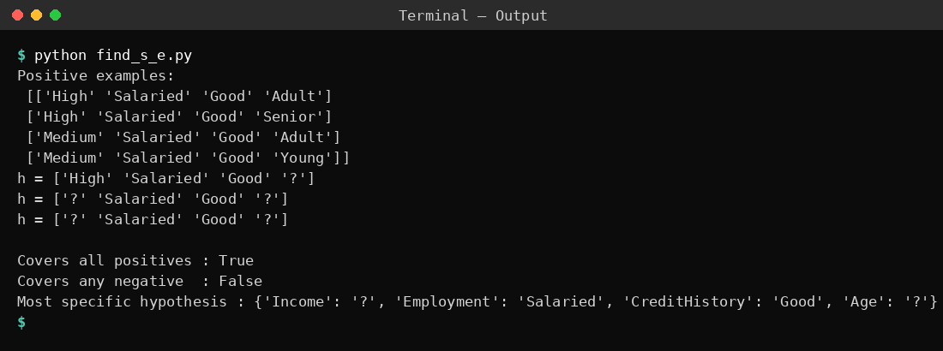
Result
The most specific hypothesis obtained is <?, Salaried, Good, ?>. The verification shows that it covers all positive examples and none of the negative examples, so loans are approved for salaried applicants with a good credit history.

